**CN Assignment 6**

Name: Erwin Wu

Affiliation: Koike Lab

Student ID: 17M38147

**Application of Complex Networks**

The class held on Jan.29th summarized about Complex Social Networks and the class on Feb.1st introduced some application of complex networks.

Most larger social networks display features of social complexity, which involves substantial non-trivial features of network topology, with patterns of complex connections between elements that are neither purely regular nor purely random, as do biological, and technological networks.

Complex networks require methods specific to modelling and interpreting social complexity and complex adaptive systems, including techniques of dynamic network analysis. Mechanisms such as Dual-phase evolution explain how temporal changes in connectivity contribute to the formation of structure in social networks.

During the class, the teacher mentioned the six degrees of separation theory, that is the idea that everything in the world can be related in six steps or fewer away from each other. So that a chain of “a friend of a friend” statements can be made to connect any two people in maximum of 4 people between them, as the figure showing below:

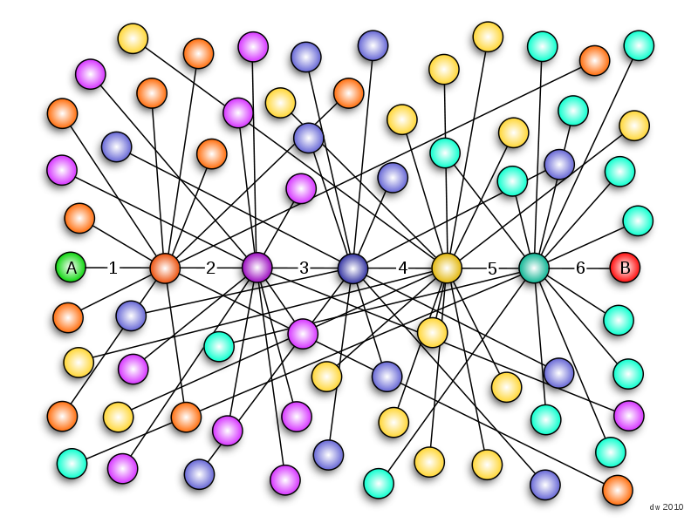

Fig 1. Six degrees of separation

My major research is about deep learning, I’m thinking of applying it to Social Networks. For example, the link prediction problem has always been popular among social networks research. Link prediction is to forecast the development (or we can say the trend) of the relationship between nodes with the existed network. It’s quite important in social network because we can predict one person’s social intercourse or even his behavior and his role in the society. While deep learning-based link prediction might be a good solution for social network forecasting.

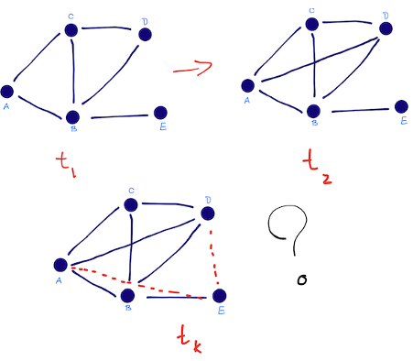

Fig 2. Link prediction [1]

As we learnt from the class, social networks are highly dynamic objects which grow and change quickly over time through the addition of new edges, signifying the appearance of new interactions in the underlying social structure. There are some previous research dealing with link prediction by link-based methods[2], however they almost account only for the link structures of networks and ignore the node attributes which are in face also useful for link prediction. On the other hand, deep neural network is possible to learn the features of attributes and the changes of them on time sequence. (For example, the LSTM model [3]). I believe by jointly modeling the node attributes and link structures, link prediction can get the best of both worlds and deliver state-of-the-art performance for Social Network.

[1] Link Prediction Algorithms [2018-02-03]: <http://be.amazd.com/link-prediction/>

[2] Hunter, D.; Smyth, P.; Vu, D. Q.; and Asuncion, A. U. 2011.Dynamic egocentric models for citation networks. In ICML,857–864.

[3] Understanding LSTM Networks [2018-02-03]: http://colah.github.io/posts/2015-08-Understanding-LSTMs/

[4] Six degrees of separation, <https://en.wikipedia.org/wiki/Six_degrees_of_separation>